2024

Vipul Dessai

[Awesome Compony]

2/24/2024

DSA – Stack

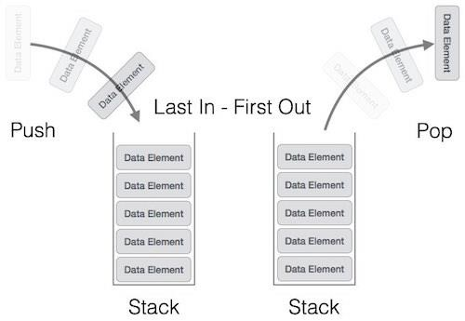

Contents

Next Greater Element I 2

Intuition 2

Complexity 2

Solution 2

# [Next Greater Element I](https://leetcode.com/problems/next-greater-element-i/)

## Intuition

Use monotonic stack and store the **nums1** next greater item in a HashMap

## Complexity

TC - O(N + M)

SC – O(N)

## [Solution](https://leetcode.com/problems/next-greater-element-i/solutions/5016587/simple-solution-with-stack-and-hashmap-with-explaination)